Important Reminders

April 4th: All School Picture

April 10th: Mid-Quarter

April 12th: Musical Seussical @ 11:30

April 12th: Talent Show Preview

April 13th: Talent Show & Taco Bar

April 18th: Early Out @ 12

April 19th – 22nd: Easter Break

This Week in Kindergarten We Are Working On:

* Phonemic Awareness, Phonics, Handwriting
* Science: Force/Objects
* Math: Reasoning & Proof
* Social Studies: Desert Habitat
* Learning how to write an email

March 29th, 2019

Note from Mrs. Neel

It’s been an awesome week in Kindergarten! All students have worked very hard in class. I’m so proud of them!

Mrs. Neel

**Sight Words Next Week**

come number

way write

them (review) would

just than

look (review) his

**April Snack Schedule**

April 1st – 5th (Emma & Willa)

April 8th – 12th (Grayson)

April 15th – 17th (Left Overs)

April 23rd – 26th (Lila)

April 29th – May 16th (Left Overs)

**Book-It Program ends in March. Students will be reading towards a prize out of the treasure box, for the month of April.**

**April Reading Goal**

**15 days/20 minutes per day**

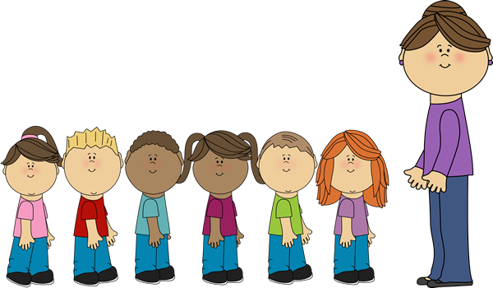Kindergarten News